**Neural Network Graphs-**

**From Scratch:**

Number of Hidden Layers: 2, Neurons per Layer: 5, 5. Learning Rate: 0.01

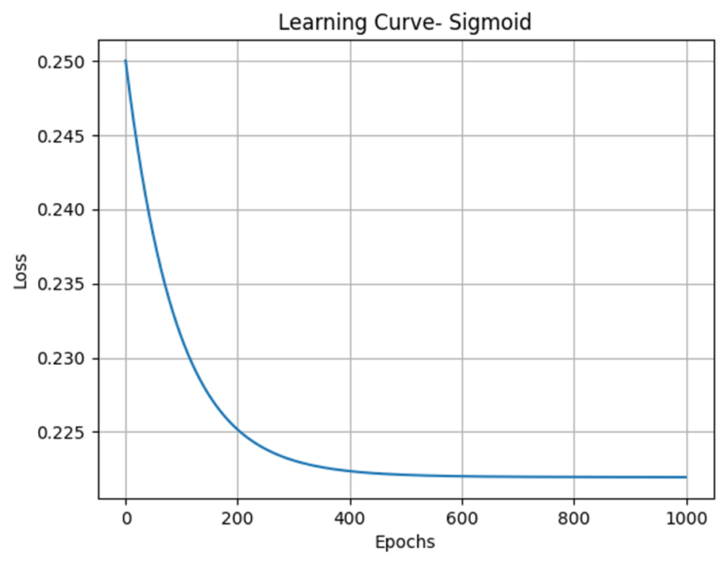

Number of Hidden Layers: 2, Neurons per Layer: 10, 10. Learning Rate: 0.01

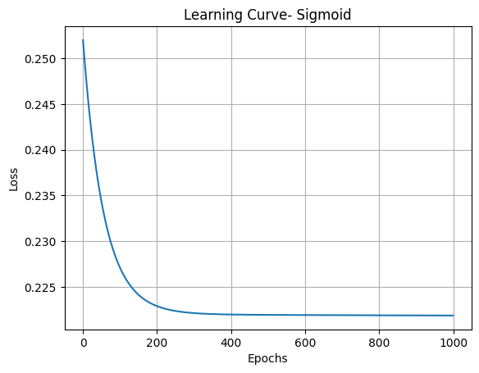

Number of Hidden Layers: 3, Neurons per Layer: 4, 4, 2. Learning Rate: 0.01

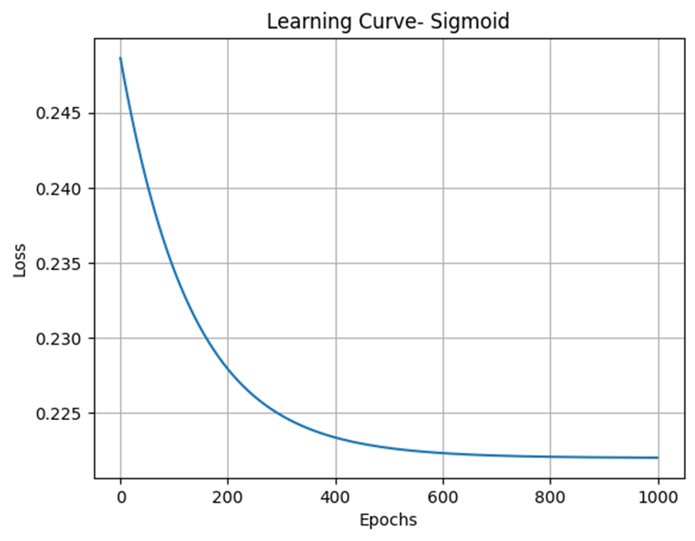

*Reducing Number of Hidden Layers since increasing them did not have much of an impact

Number of Hidden Layers: 1, Neurons per Layer: 5. Learning Rate: 0.01

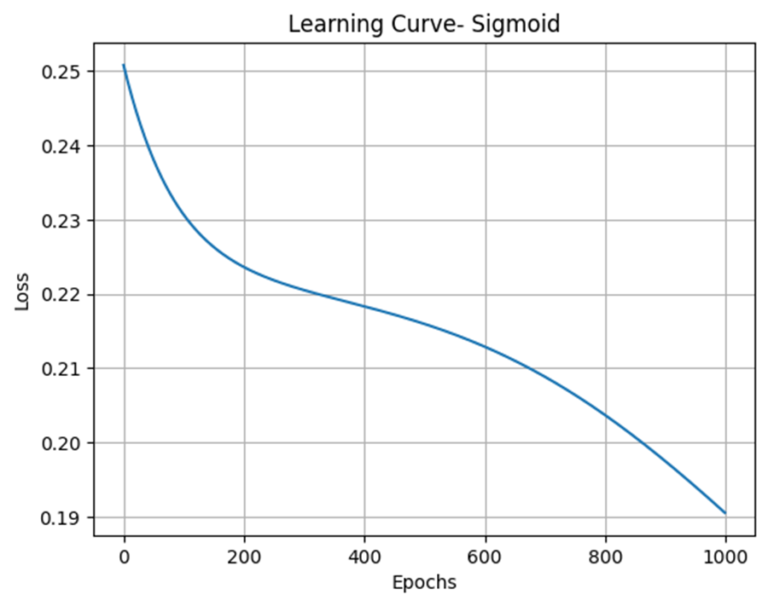

Number of Hidden Layers: 2, Neurons per Layer: 5, 5. Learning Rate: 0.1

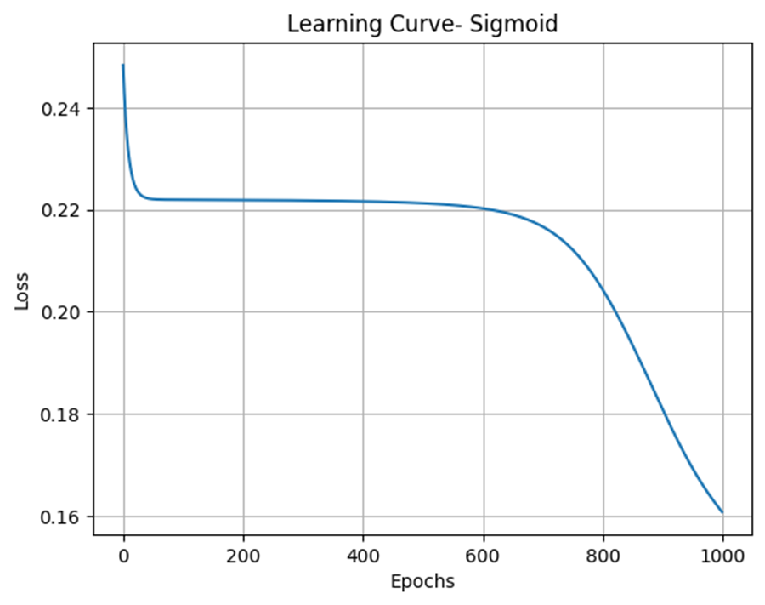

Number of Hidden Layers: 3, Neurons per Layer: 4, 4, 2. Learning Rate: 0.1

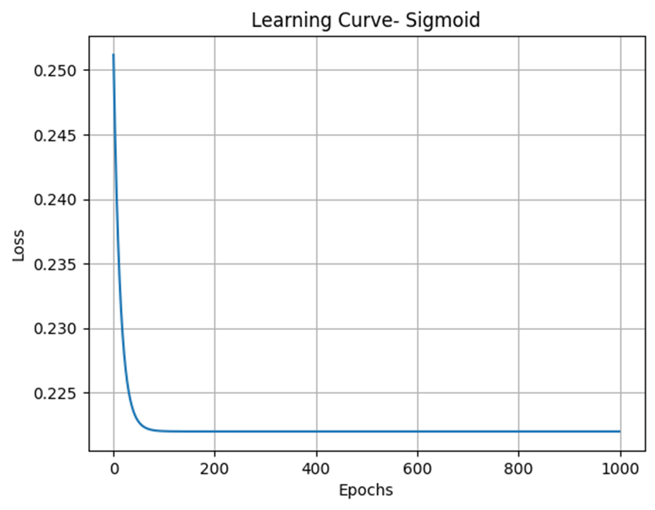

Number of Hidden Layers: 1, Neurons per Layer: 5. Learning Rate: 0.1

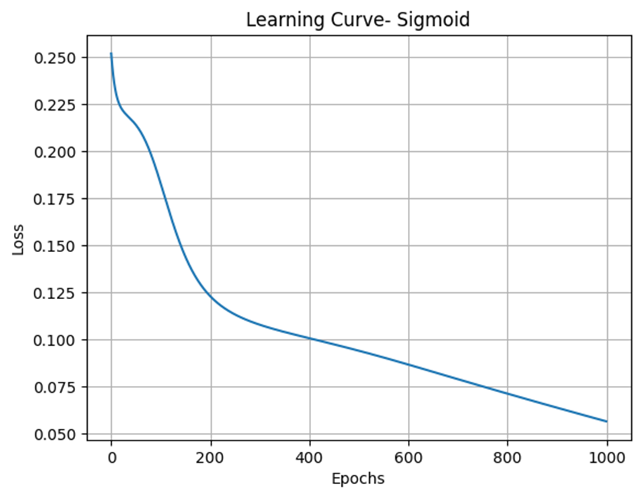

Number of Hidden Layers: 2, Neurons per Layer: 5, 5. Learning Rate: 0.03

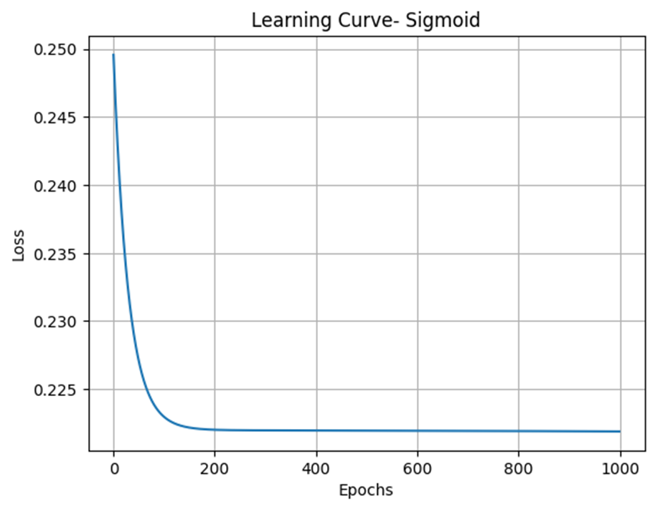

Number of Hidden Layers: 2, Neurons per Layer: 10, 10. Learning Rate: 0.03

(Same number of hidden layers but different number of neurons per layer did not really have an impact either time)

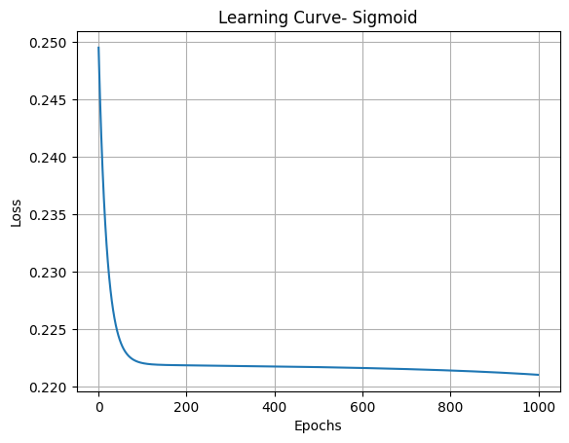

Number of Hidden Layers: 3, Neurons per Layer: 4, 4, 2. Learning Rate: 0.03

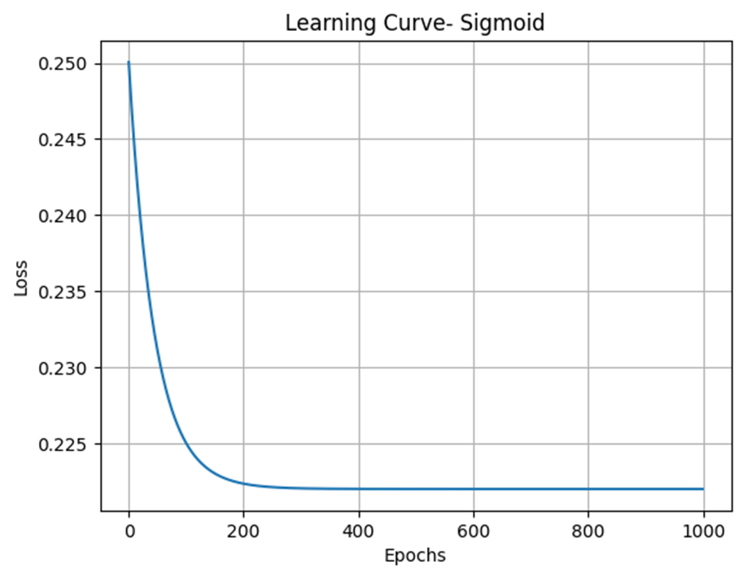

Number of Hidden Layers: 1, Neurons per Layer: 5. Learning Rate: 0.03

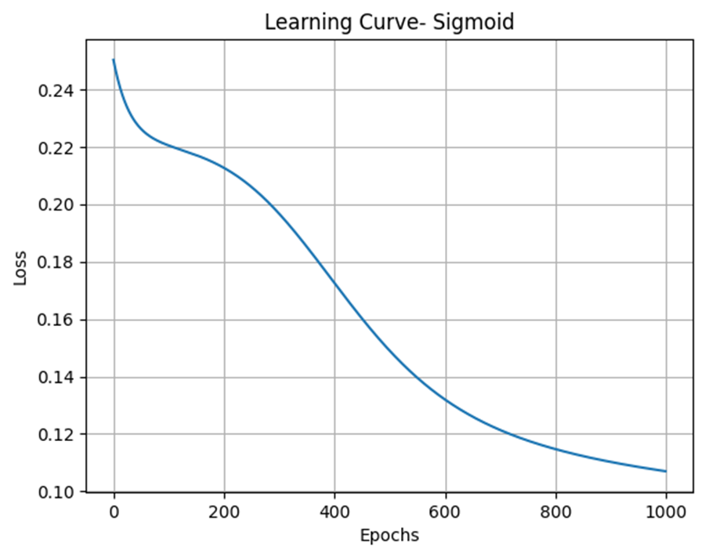

Number of Hidden Layers: 2, Neurons per Layer: 5, 5. Learning Rate: 0.3

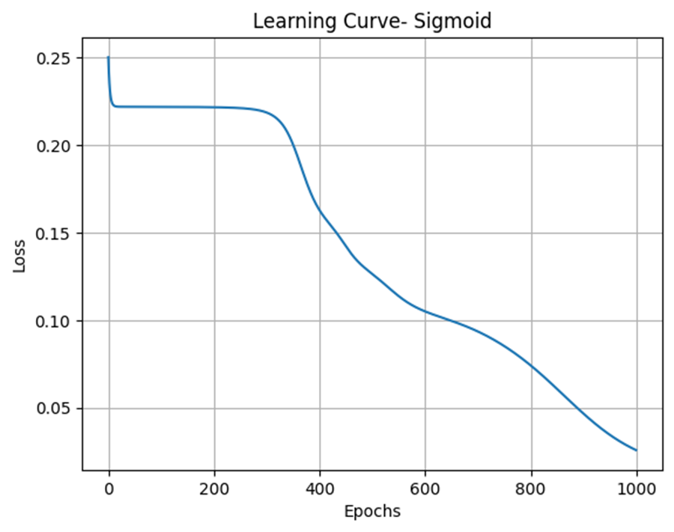

Number of Hidden Layers: 3, Neurons per Layer: 4, 4, 2. Learning Rate: 0.3

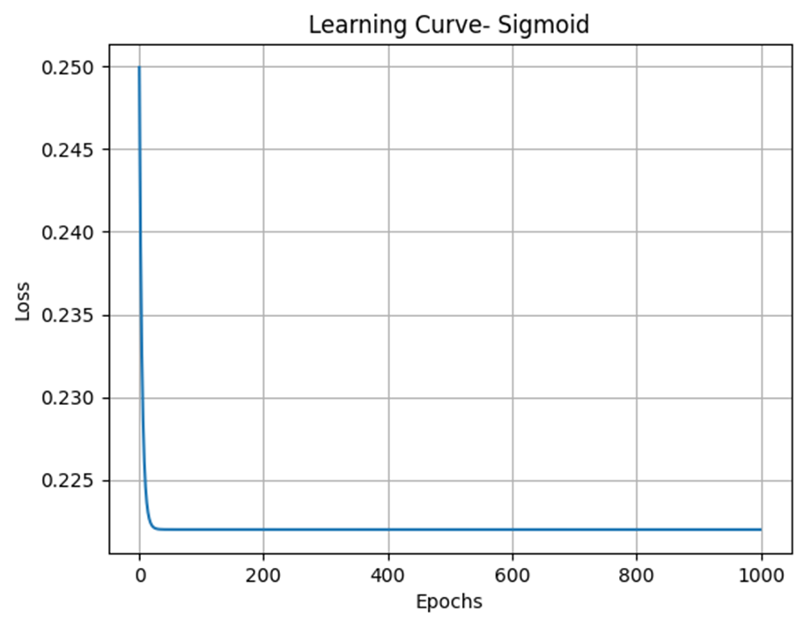

Number of Hidden Layers: 1, Neurons per Layer: 5. Learning Rate: 0.3

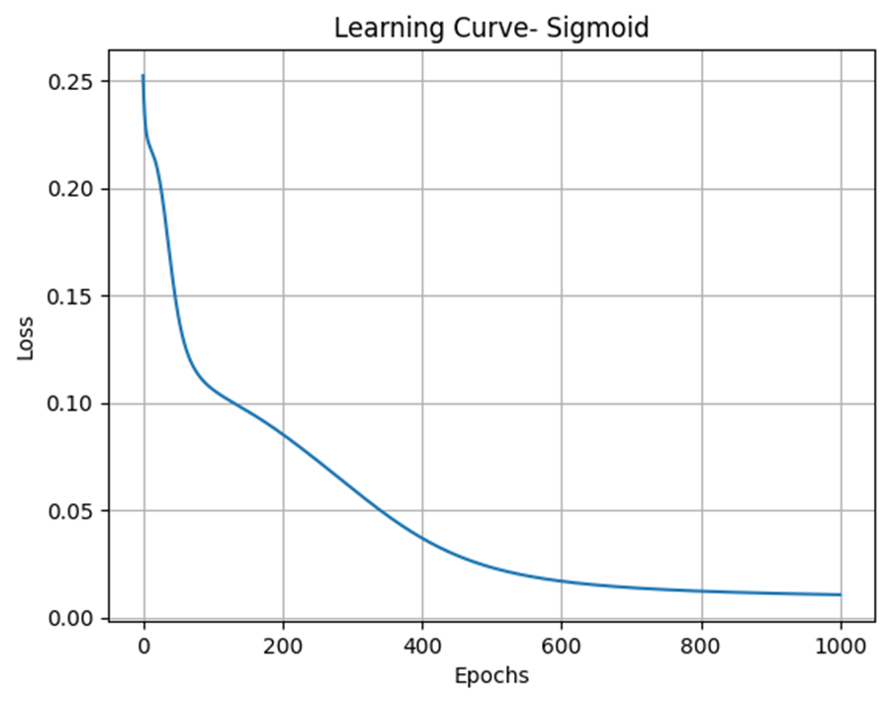

**MUCH BIGGER IMPACT!

-Now to do this all with another activation function for comparison

ReLU-

Number of Hidden Layers: 2, Neurons per Layer: 5, 5. Learning Rate: 0.01

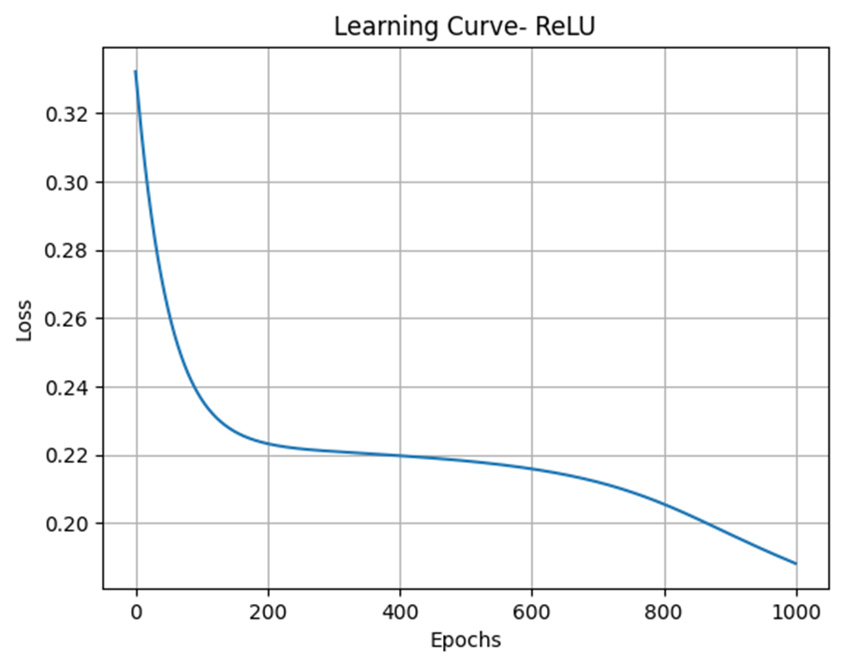

Number of Hidden Layers: 2, Neurons per Layer: 10, 10. Learning Rate: 0.01

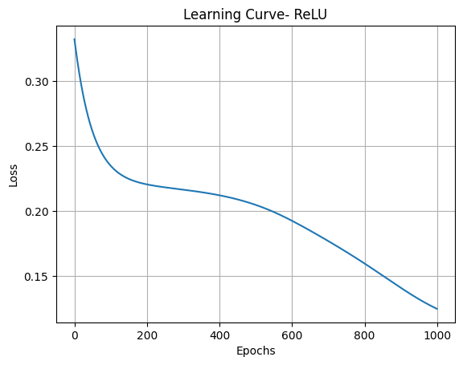

Changing Number of Hidden Layers and Neurons Per Layer-

Number of Hidden Layers: 3, Neurons per Layer: 4, 4, 2. Learning Rate: 0.01

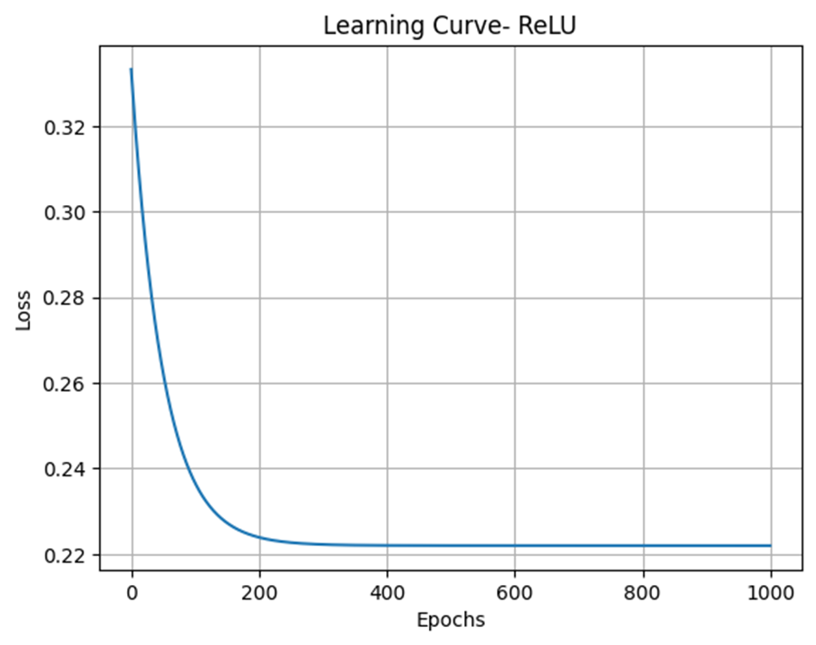

*Let’s reduce the number of layers here too for comparison

Number of Hidden Layers: 1, Neurons per Layer: 5. Learning Rate: 0.01

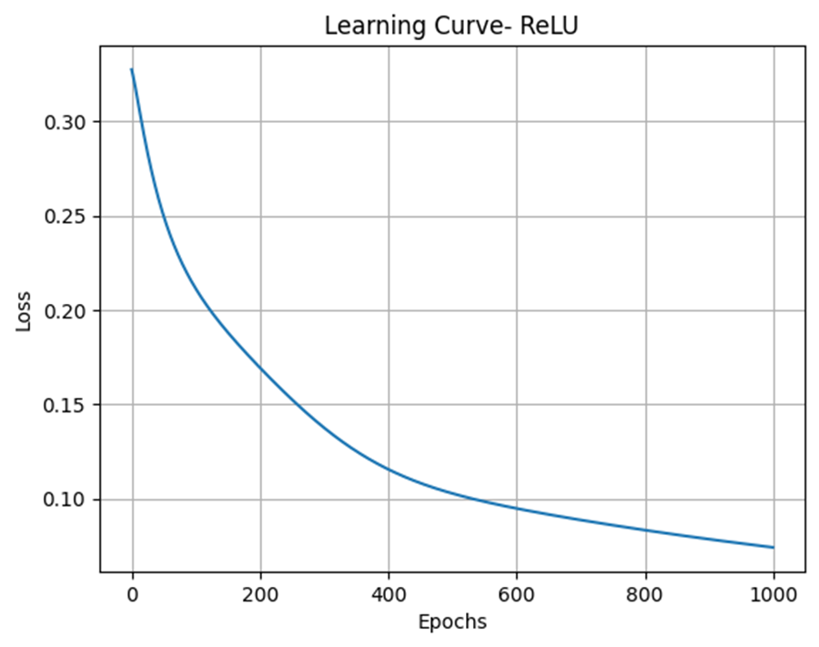

Number of Hidden Layers: 2, Neurons per Layer: 5, 5. Learning Rate: 0.1

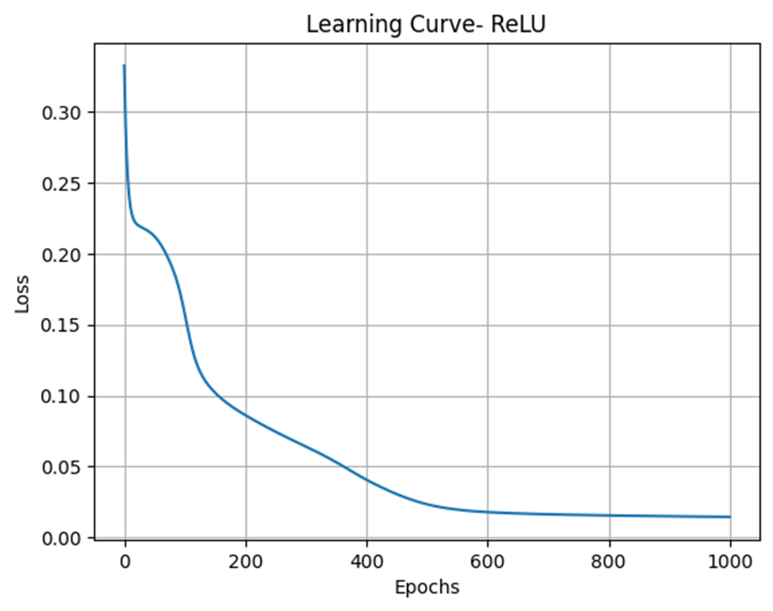

Number of Hidden Layers: 2, Neurons per Layer: 10, 10 Learning Rate: 0.1

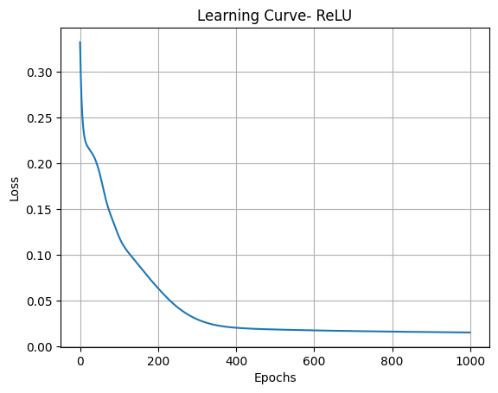

Number of Hidden Layers: 3, Neurons per Layer: 4, 4, 2. Learning Rate: 0.1

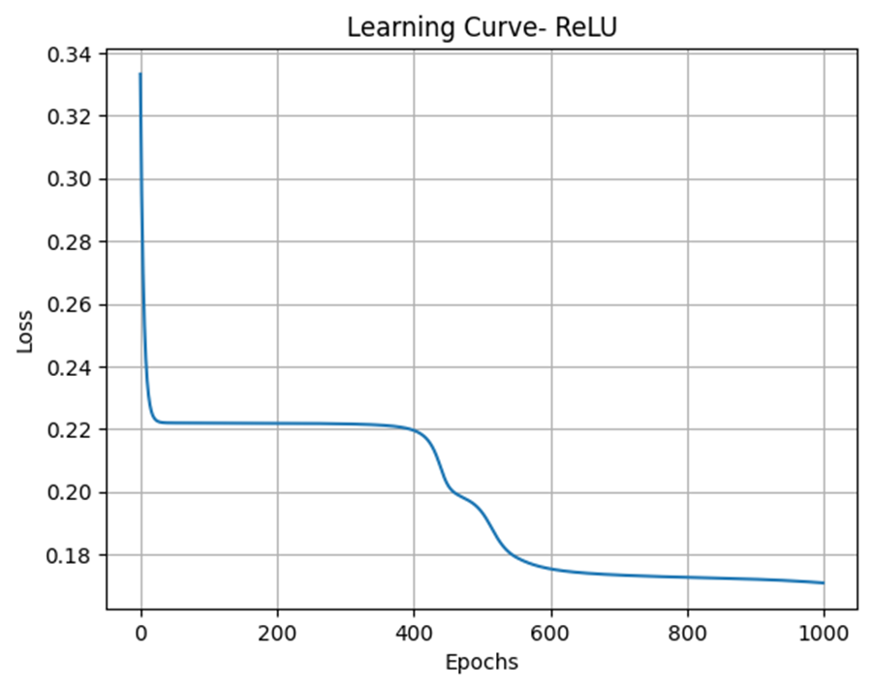

Number of Hidden Layers: 1, Neurons per Layer: 5. Learning Rate: 0.1

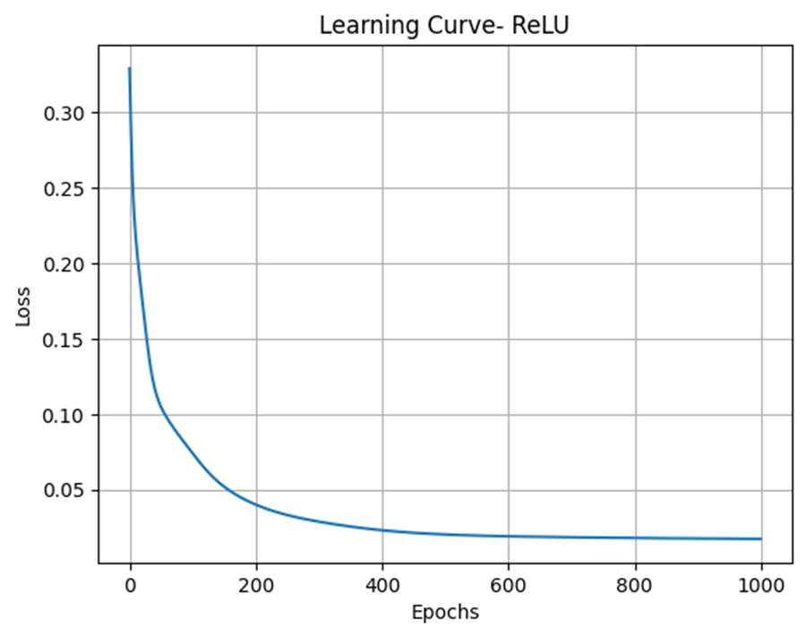

Number of Hidden Layers: 2, Neurons per Layer: 5, 5. Learning Rate: 0.03 (cross validation accuracy was high here!)

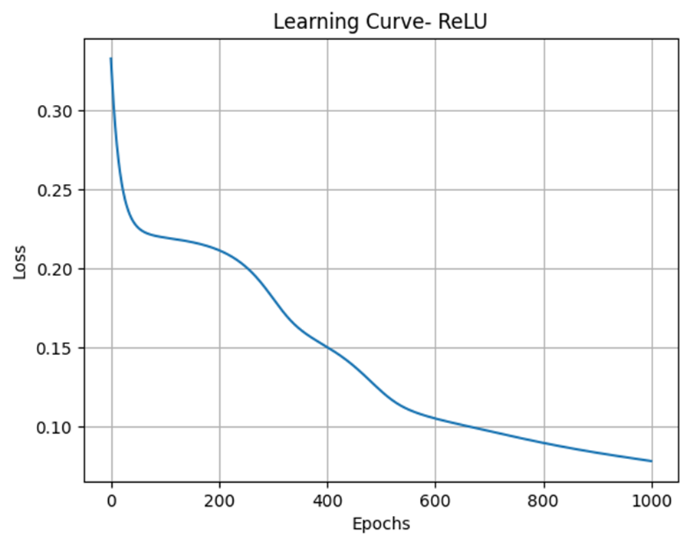

Number of Hidden Layers: 2, Neurons per Layer: 10, 10 Learning Rate: 0.03

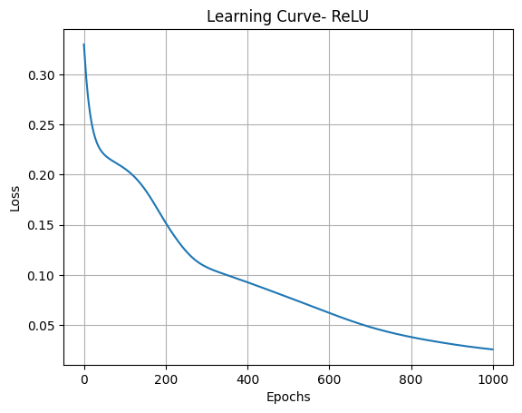

Number of Hidden Layers: 3, Neurons per Layer: 4, 4, 2. Learning Rate: 0.03

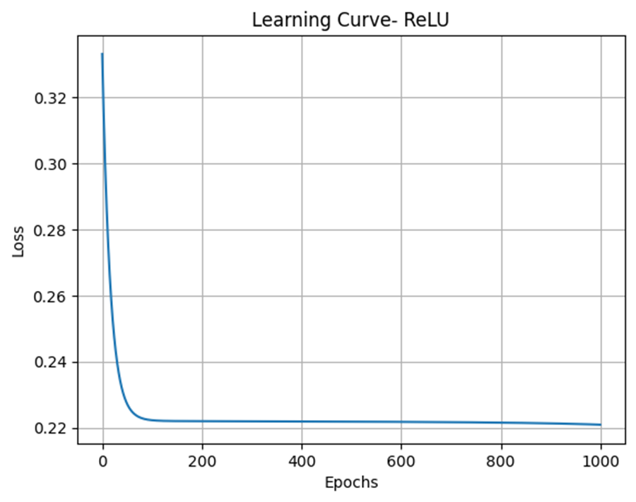

Number of Hidden Layers: 1, Neurons per Layer: 5. Learning Rate: 0.03

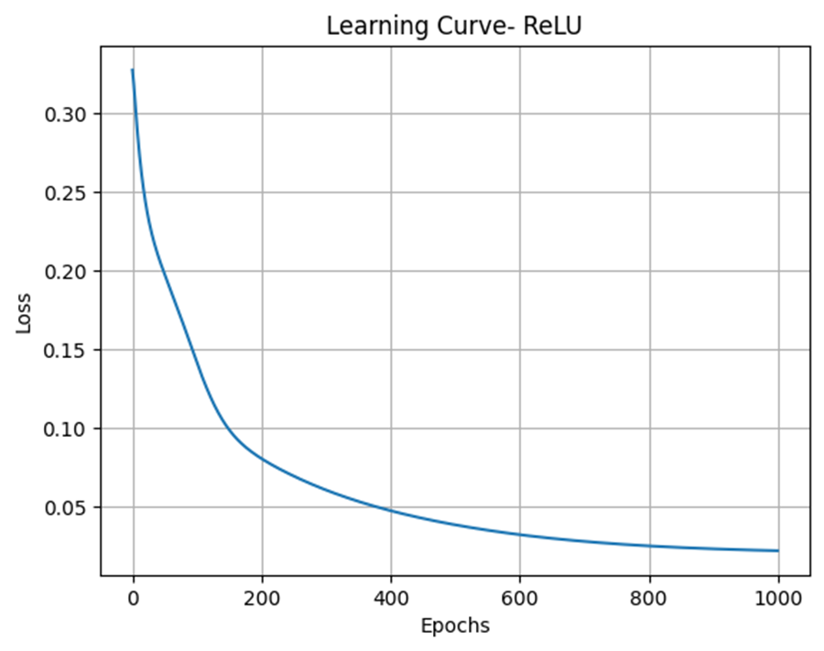

Number of Hidden Layers: 2, Neurons per Layer: 5, 5. Learning Rate: 0.3

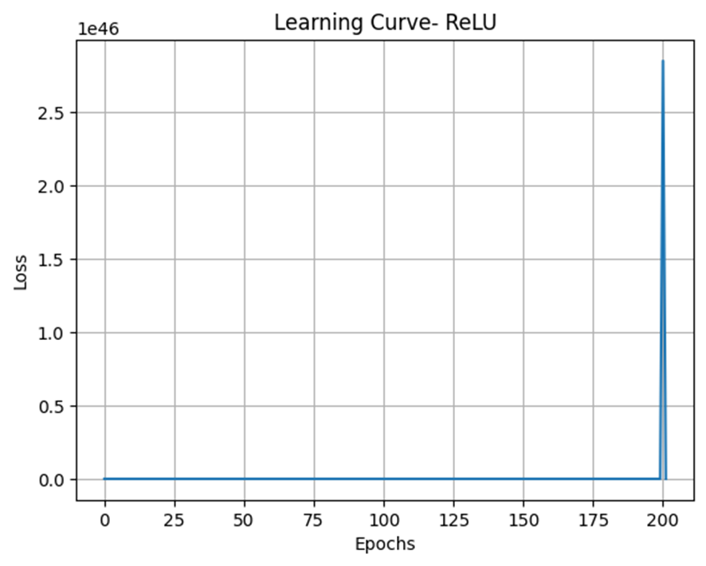

(Cross validation accuracy here plummeting. Increased layers give less accurate results here too)

Number of Hidden Layers: 3, Neurons per Layer: 4, 4, 2. Learning Rate: 0.3

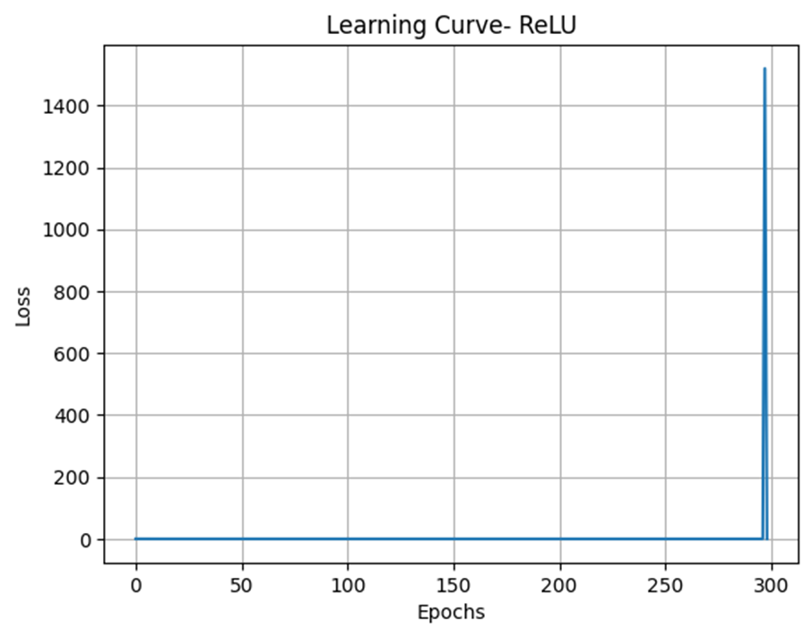

Number of Hidden Layers: 1, Neurons per Layer: 5. Learning Rate: 0.3

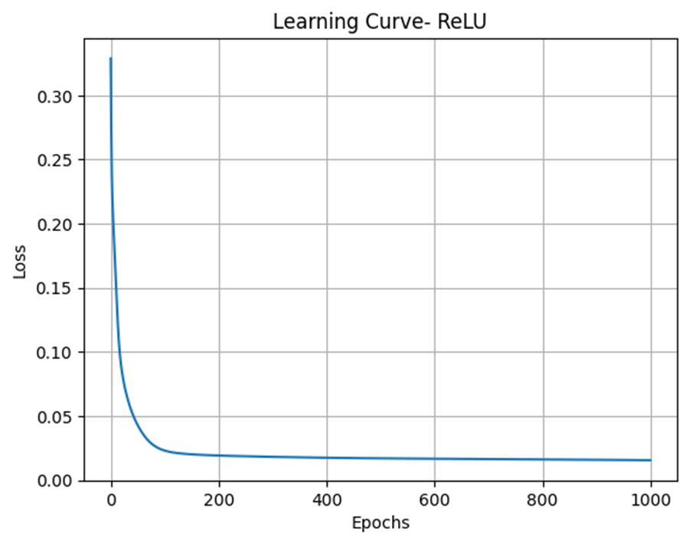

**By reducing the number of hidden layers, the learning rate did not have nearly as much of an affect on the learning curve as previous ones did.

TanH-

Number of Hidden Layers: 2, Neurons per Layer: 5, 5. Learning Rate: 0.01

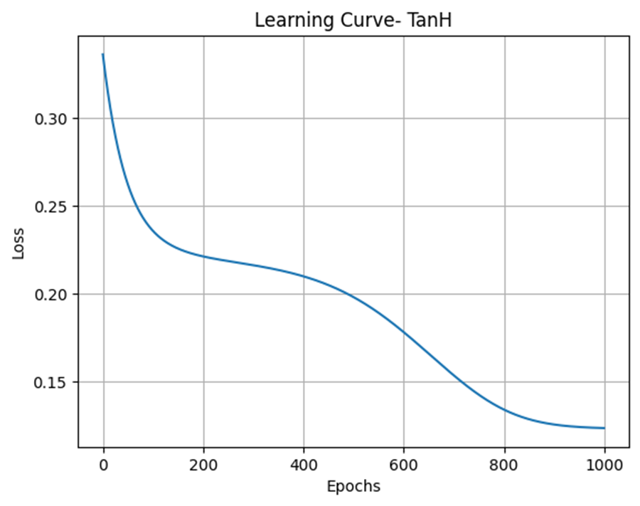

Number of Hidden Layers: 2, Neurons per Layer: 10, 10. Learning Rate: 0.01

(Increased number of neurons but kept just 2 layers)

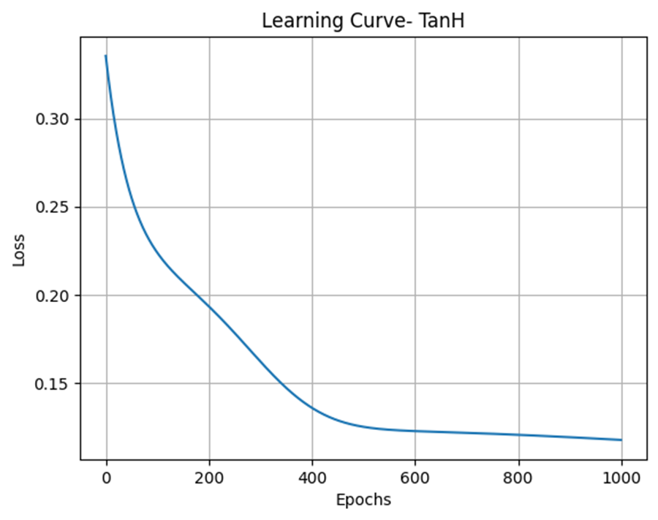

Number of Hidden Layers: 3, Neurons per Layer: 4, 4, 2. Learning Rate: 0.01

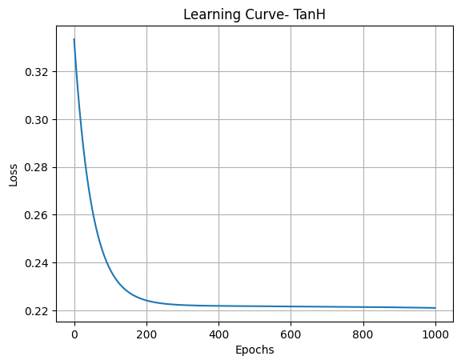

Number of Hidden Layers: 1, Neurons per Layer: 5. Learning Rate: 0.01

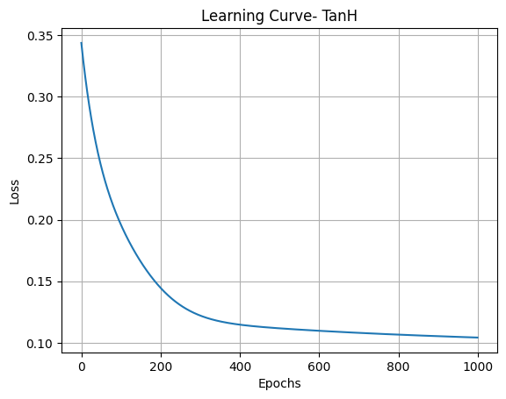

Number of Hidden Layers: 2, Neurons per Layer: 10, 10. Learning Rate: 0.1

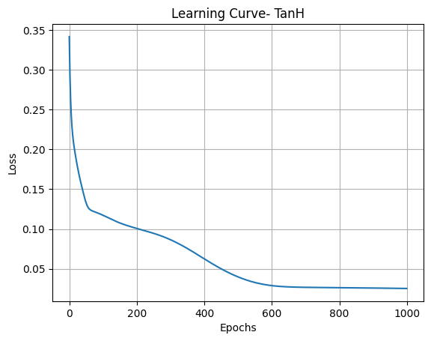

Number of Hidden Layers: 3, Neurons per Layer: 4, 4, 2. Learning Rate: 0.1

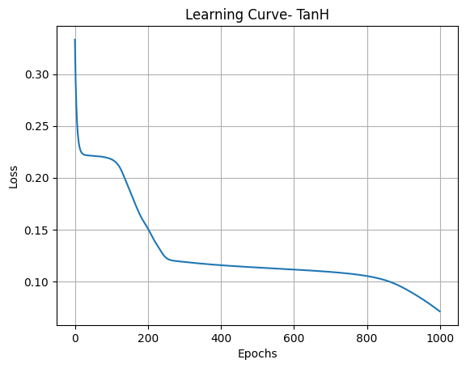

Number of Hidden Layers: 1, Neurons per Layer: 5. Learning Rate: 0.1

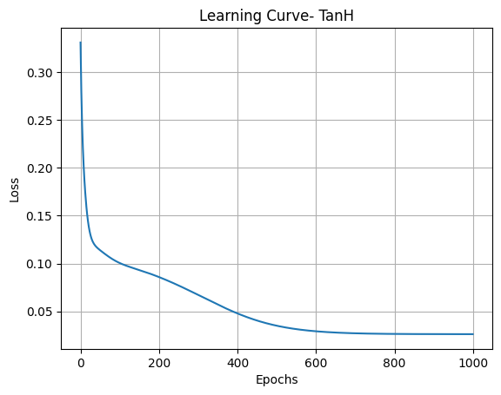

Number of Hidden Layers: 2, Neurons per Layer: 10, 10. Learning Rate: 0.03

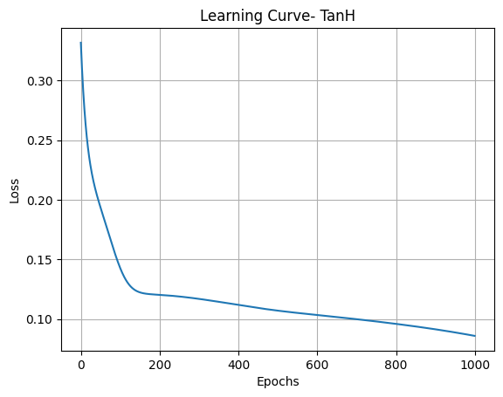

Number of Hidden Layers: 3, Neurons per Layer: 4, 4, 2. Learning Rate: 0.03

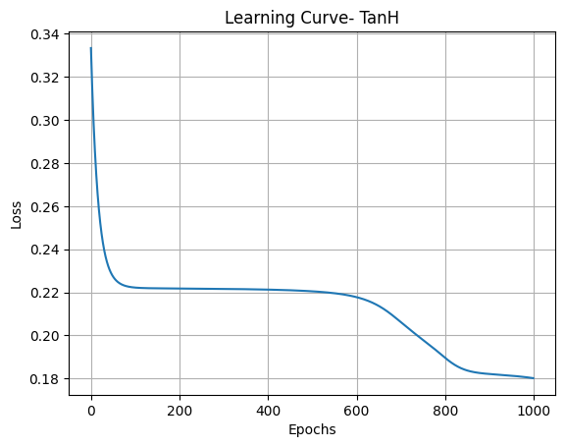

Number of Hidden Layers: 1, Neurons per Layer: 5. Learning Rate: 0.03

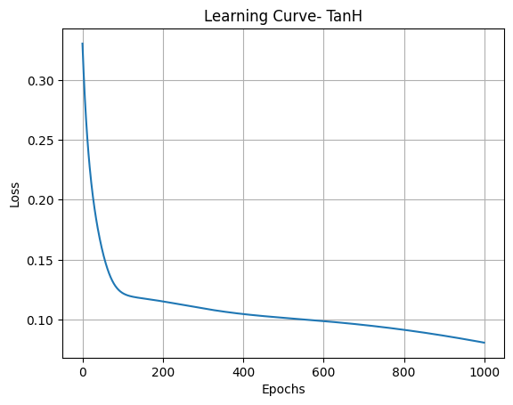

Number of Hidden Layers: 2, Neurons per Layer: 10, 10. Learning Rate: 0.3

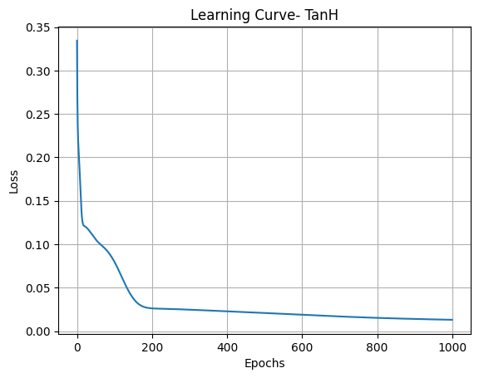

Number of Hidden Layers: 3, Neurons per Layer: 4, 4, 2. Learning Rate: 0.3

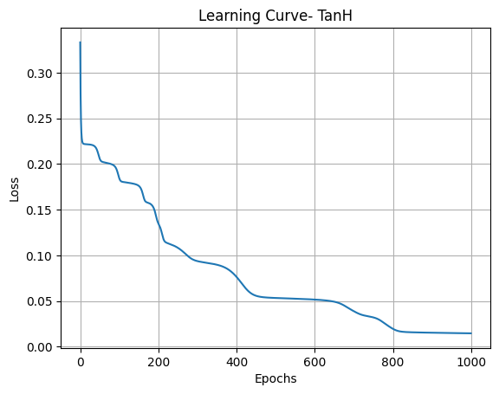

Number of Hidden Layers: 1, Neurons per Layer: 5. Learning Rate: 0.3

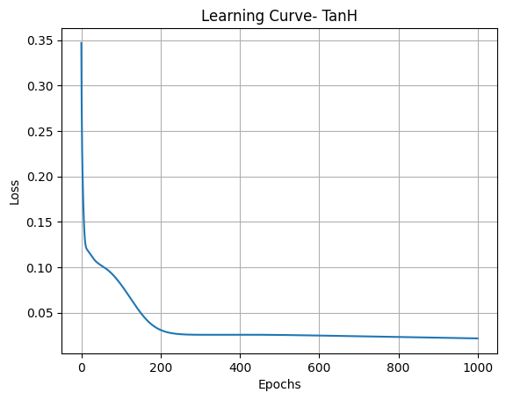

SKLEARN-

Number of Hidden Layers: 2, Neurons Per Layer: 5, 5, Learning Rate: 0.01

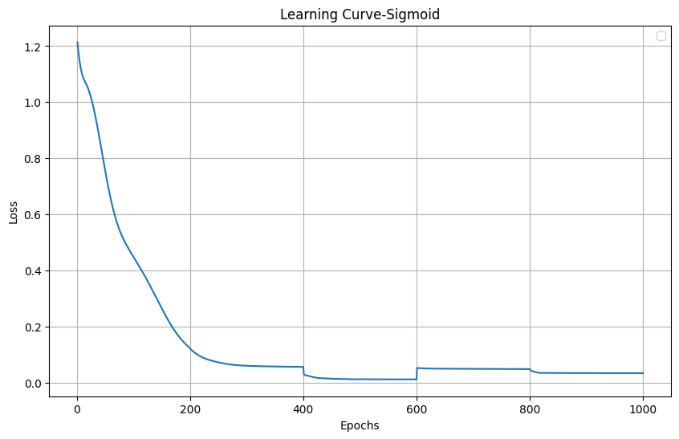

Number of Hidden Layers: 2, Neurons Per Layer: 10, 10, Learning Rate: 0.01

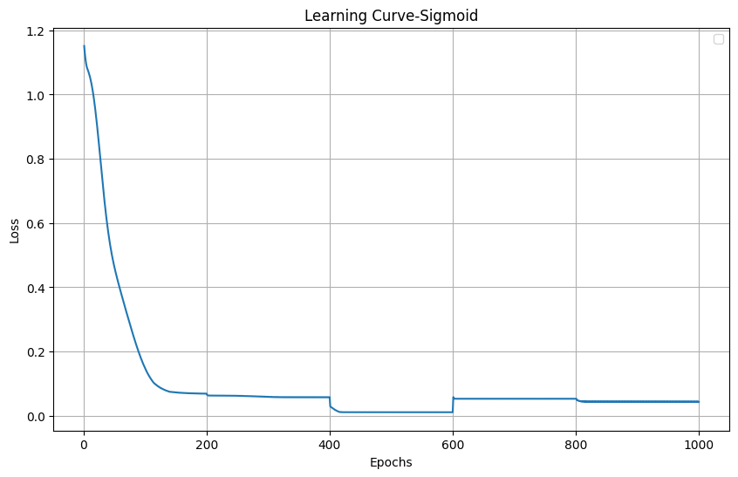

Number of Hidden Layers: 3, Neurons Per Layer: 4, 4, 2, Learning Rate: 0.01

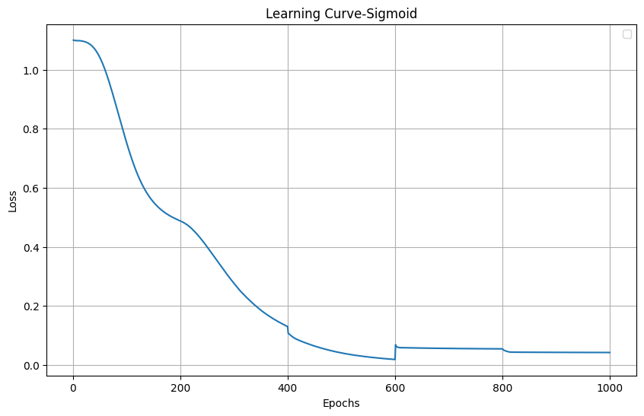

Number of Hidden Layers: 1, Neurons Per Layer: 5, Learning Rate: 0.01

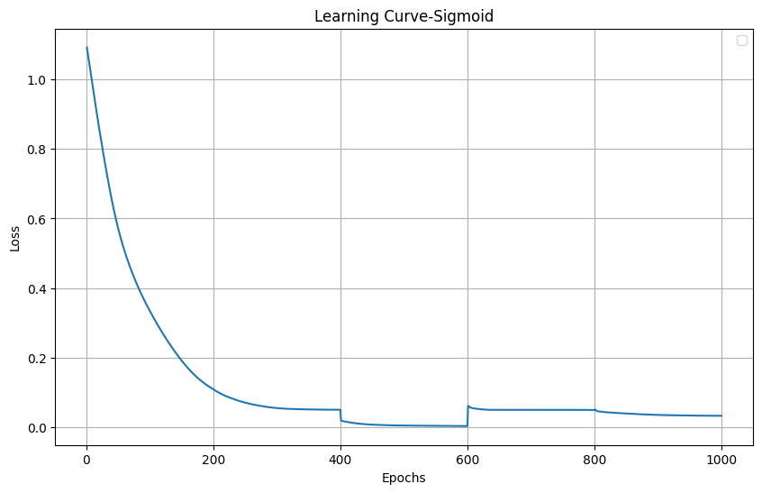

0.1,

Number of Hidden Layers: 2, Neurons per Layer: 5, 5. Learning Rate: 0.1

Number of Hidden Layers: 2, Neurons per Layer: 10, 10. Learning Rate: 0.1

Number of Hidden Layers: 3, Neurons per Layer: 4, 4, 2. Learning Rate: 0.1

Number of Hidden Layers: 1, Neurons per Layer: 5. Learning Rate: 0.1

0.03

Number of Hidden Layers: 2, Neurons per Layer: 5, 5. Learning Rate: 0.03

Number of Hidden Layers: 2, Neurons per Layer: 10, 10. Learning Rate: 0.03

Number of Hidden Layers: 3, Neurons per Layer: 4, 4, 2. Learning Rate: 0.03

Number of Hidden Layers: 1, Neurons per Layer: 5. Learning Rate: 0.03

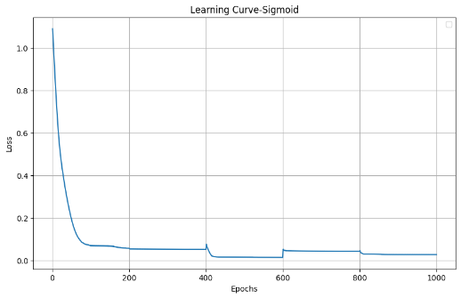

ReLU

Number of Hidden Layers: 2, Neurons per Layer: 5, 5. Learning Rate: 0.01

Number of Hidden Layers: 2, Neurons per Layer: 10, 10. Learning Rate: 0.01

Number of Hidden Layers: 3, Neurons per Layer: 4, 4, 2. Learning Rate: 0.01

Number of Hidden Layers: 1, Neurons per Layer: 5. Learning Rate: 0.01

0.1,

Number of Hidden Layers: 2, Neurons per Layer: 5, 5. Learning Rate: 0.1

Number of Hidden Layers: 2, Neurons per Layer: 10, 10. Learning Rate: 0.1

Number of Hidden Layers: 3, Neurons per Layer: 4, 4, 2. Learning Rate: 0.1

Number of Hidden Layers: 1, Neurons per Layer: 5. Learning Rate: 0.1

0.03

Number of Hidden Layers: 2, Neurons per Layer: 5, 5. Learning Rate: 0.03

Number of Hidden Layers: 2, Neurons per Layer: 10, 10. Learning Rate: 0.03

Number of Hidden Layers: 3, Neurons per Layer: 4, 4, 2. Learning Rate: 0.03

Number of Hidden Layers: 1, Neurons per Layer: 5. Learning Rate: 0.03

0.3

Number of Hidden Layers: 2, Neurons per Layer: 5, 5. Learning Rate: 0.3

Number of Hidden Layers: 2, Neurons per Layer: 10, 10. Learning Rate: 0.3

Number of Hidden Layers: 3, Neurons per Layer: 4, 4, 2. Learning Rate: 0.3

Number of Hidden Layers: 1, Neurons per Layer: 5. Learning Rate: 0.3

TanH

Number of Hidden Layers: 2, Neurons per Layer: 5, 5. Learning Rate: 0.01

Number of Hidden Layers: 2, Neurons per Layer: 10, 10. Learning Rate: 0.01

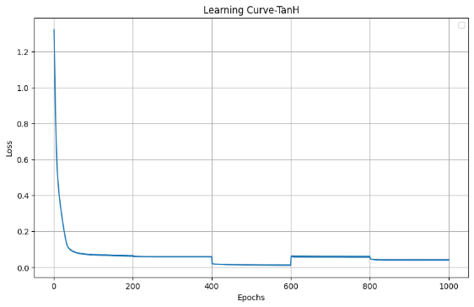

Number of Hidden Layers: 3, Neurons per Layer: 4, 4, 2. Learning Rate: 0.01

Cross-validation accuracy: 0.6000

Number of Hidden Layers: 1, Neurons per Layer: 5. Learning Rate: 0.01

C. V 0.3333

0.1,

Number of Hidden Layers: 2, Neurons per Layer: 5, 5. Learning Rate: 0.1

Number of Hidden Layers: 2, Neurons per Layer: 10, 10. Learning Rate: 0.1

Number of Hidden Layers: 3, Neurons per Layer: 4, 4, 2. Learning Rate: 0.1

C V 0.3333

Number of Hidden Layers: 1, Neurons per Layer: 5. Learning Rate: 0.1

C. V 0.3333

0.03

Number of Hidden Layers: 2, Neurons per Layer: 5, 5. Learning Rate: 0.03

Number of Hidden Layers: 2, Neurons per Layer: 10, 10. Learning Rate: 0.03

Number of Hidden Layers: 3, Neurons per Layer: 4, 4, 2. Learning Rate: 0.03

C V 0.4000

Number of Hidden Layers: 1, Neurons per Layer: 5. Learning Rate: 0.03

C. V 0.333

0.3

Number of Hidden Layers: 2, Neurons per Layer: 5, 5. Learning Rate: 0.3

Number of Hidden Layers: 2, Neurons per Layer: 10, 10. Learning Rate: 0.3

Cross-Validation Accuracy: 0.3533

Number of Hidden Layers: 3, Neurons per Layer: 4, 4, 2. Learning Rate: 0.3

C. V 0.333

Number of Hidden Layers: 1, Neurons per Layer: 5. Learning Rate: 0.3

C. V 0.333